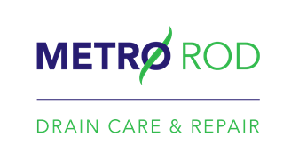
Dear Valued Customer
As we navigate our way through these extraordinary times, I have been exploring what further support Metro Rod can offer to our loyal customers.
I am sure that like Metro Rod and the rest of the country most of your staff are working from home. This, combined with the significant supply shortage of toilet tissue caused by panic buying, means people are likely to flush items down the toilet which are not designed to degrade, such as wet wipes and kitchen towel. This increases the risk that drains and sewage systems will block more frequently.
I would like to extend an offer to all your staff which I trust will be supportive.
If they experience a blockage at home or if they have a water leak, they can call Metro Rod or Metro Plumb and we will undertake the work at the commercial prices we have already agreed with you.
We have over 400 plumbing and drainage engineers operating in nearly 50 locations across the UK 24/7. Metro Rod is currently operating a business as usual service and there is no impact on our ability to deliver our full range of services.
The process is very simple:
- We've created a handy reference to our services here - which you can distribute to all of your employees with your account number: NC0251.
- If any of your staff have a need for any of these services all they need to do is call 0800 668800 and quote the account number above. We use this to identify your account and we can then apply the commercial prices you benefit from.
- Payment will be taken via credit card.
I recognise that this is a relatively small gesture in the current circumstances, but I wanted to help where I can and to support our customers. If this is of interest can I ask you to inform your staff.
I am more than happy to discuss this with you personally and I can be contacted on 07810630034.
Kind regards,
Josh Marland
Metro Rod Ltd

